**EIBP – Performance Metrics**

1. **Downloading the Code**

Download the latest Intra-AS Code located at:

Team KCT Progress/EIBP/Code/MNLR_9th Mar 2023.

1. **Downloading Metrics Calculator**

* Download the EIBPmetrics.py file located at:

Team KCT Progress/ EIBP/Code/

* Also download the toTXT.py file located in the same folder.

Note: This file does not need to be placed inside MNLR_script. It should be in the same folder as the log files.

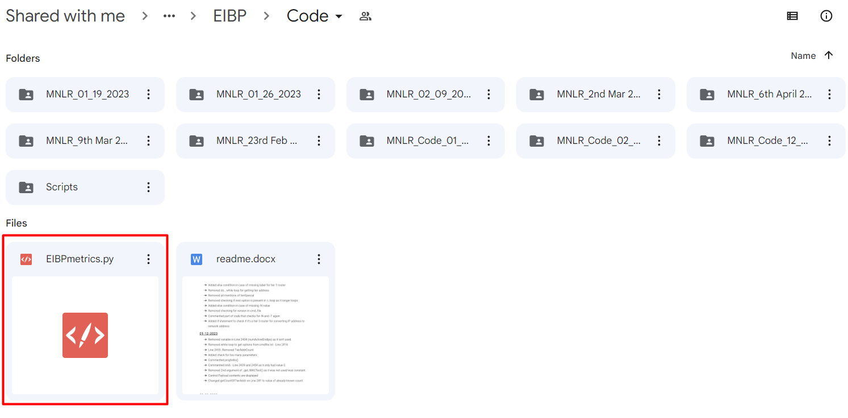

1. **Configuration Update**

Update cmd_file.txt, Credentials_Path.txt and rspec.xml as per your slice.

1. **Download Log Files**

* Run EIBP on the slice as usual using Start_MNLR.py.
* Wait for a few seconds after the script finishes.
* SSH into one of the nodes and down the nodes using:

E.g., sudo ifconfig eth2 down

* Wait for about 5-10 seconds for the network to converge.
* Download log files from all nodes and copy them to a single folder.

1. **Calculating Metrics**

* If all log files for a test are in the same folder, then copy the EIBPmetrics.py file and the toTXT.py file to that folder as below.

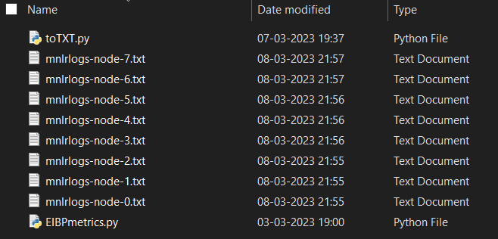

* Open Command Prompt and navigate to the folder.
* Give the following commands:
  + python toTXT.py
  + python EIBPmetrics.py
* toTXT.py converts the log files into text files so that the EIBPmetrics.py script can read them. EIBPmetrics.py computes convergence time, control overhead and churn rate and displays it as follows.

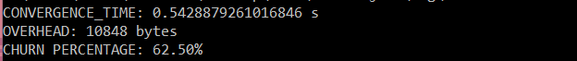

* Record these values and repeat steps 4 and 5 for each test.